What are BrainPOP Educators and My BrainPOP?
BrainPOP Educators is a collection of tips, tools, and resources to inspire and support teachers, parents, tutors, and everyone else who educates young people. Found at www.brainpop.com.educators/community, it features a blog that announces new BrainPOP features, hosts guest bloggers, and follows current events from the world of educational technology. On BrainPOP Educators you‘ll find resources including lesson plans, calendars of events, and creative suggestions for using BrainPOP in the classroom.
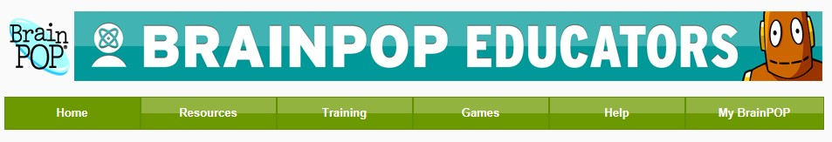

My BrainPOP lets students and teachers keep track of learning. Teachers invite their students to join "classes" they've set up on My BrainPOP. From there, they can create custom quizzes with the Mixer™, correct quizzes, comment on activities, and more. Students can see a history of the movies they’ve watched and activities they've tackled. Additionally, a selection of GameUp titles offers a "snapshot" tool so players can capture and reflect on key points.
My BrainPOP is available to BrainPOP Educators with 24/7 district- or schoolwide subscriptions. Check the U drive for your school’s log in information My BrainPOP educator codes in the Technology Resources folder.

To get started, you will need a BrainPOP Educators account:
- Go to https://secure.brainpop.com/educators/registration/.
- Follow the steps to create your individual BrainPOP Educators account. Make sure you select the correct school.
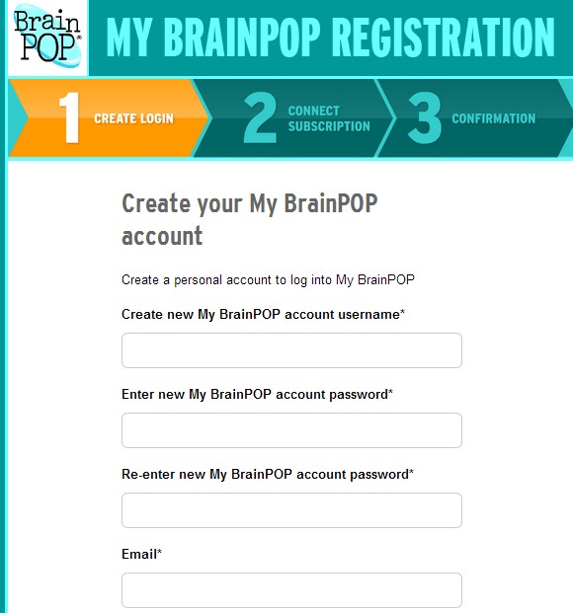
What will you find on BrainPOP Educators?

Free resources:
  - movie ideas, activity pages, and answer keys
  - lessons plans by subject and grade level
  - webinars and video tutorials
  - graphic organizers
  - mobile apps
  - games for interactive whiteboards
  - calendars, posters, certificates, and stickers
  - game-based learning resources
  - FAQs

- Next, connect your individual educator’s account to your school district account.
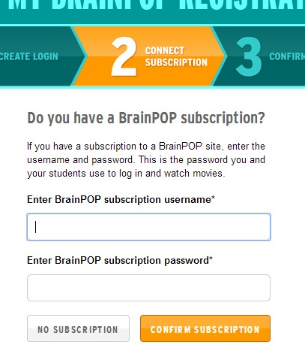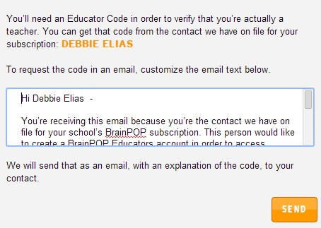

- Verify your permission to access your school’s BrainPOP/BrainPOP, Jr. subscription by entering the educator verification codes found on the U drive in the Technology Resources folder. If you are unable to locate the folder on the U drive, you can also click on Help Me Get My Code to send an email to Debbie Elias.
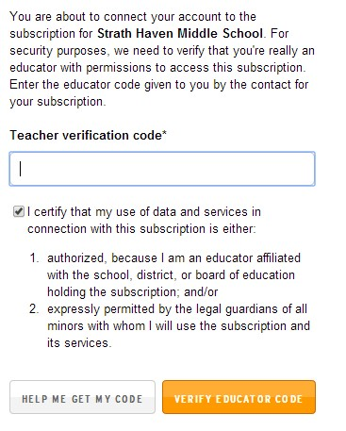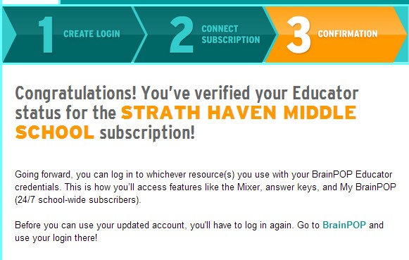

Make sure you are logged
out of your school account
when you first go to log in
with
you
r

new educator’s
account.

Getting Started with MY BrainPOP
- Log on to http://www.brainpop.com/ and click Are You an Educator? Click Yes to log in.
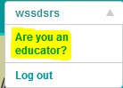
My BrainPOP, My Mixer Quizzes, and My
Classes are only a
vailable for BrainPOP
grades 3
-
8
. BrainPOP, Jr. options
currently not available.

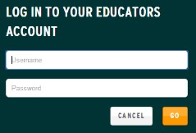
- Log in with your personal educator’s account information you just created.

- You should see three new options under your name. Click on My Classes to create student accounts to manage and monitor activity.
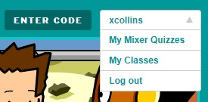

Settin
g
U
p Classes

My BrainPOP "classes" are essentially virtual classes that teachers set up to manage different groups of students. They can correspond to actual classes, but they don't have to. For example, you might set up a My BrainPOP class for all your Period 3 students; for a pull-out group; for a certain subject area; or even for an after-school club.
With a class on BrainPOP, you
- To set up a class, log in to BrainPOP using your BrainPOP will be able to see student Educators account and click on My BrainPOP. Then click on My Classes. progress, track quiz scores, and You’ll be prompted to create a class. Name the class and assign it a special more!
code. Your students will use this special code to join the class. Create as
many classes as you want. Each student will receive their
own username and password

to log on to BrainPOP 24/7 at school and home.
- Invite your students to join - When you set up a new “class,” you create a unique code for it, then share that code with your students.
Be sure to remind your students that they should start logging in with their new usernames and passwords – their personal accounts – instead of their school’s account.
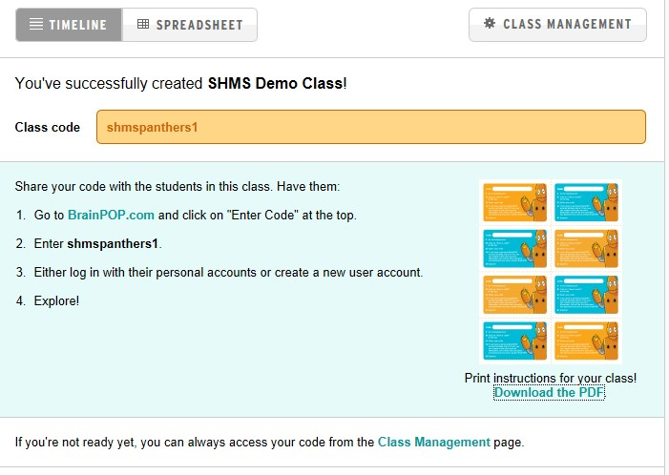

  - Direct students to BrainPOP.com and enter your class code. Then create a new user (student) account. Students will be asked to enter their first and last names, and to create a username and password. It is recommended students use their WSSD district credentials.
  - When completed, they will return the Join class screen and need to Log In.
Students now have full access to all BrainPOP resources. They can:
- Keep a history of all movies watched.
- Track the quizzes they have taken.
- Save the activities they have completed.
- See all game snapshots.
- Submit activities to a teacher.
- See comments and scores for a teacher.
Joining a class(es) - Students enter different class codes to join different classes with one personal account.
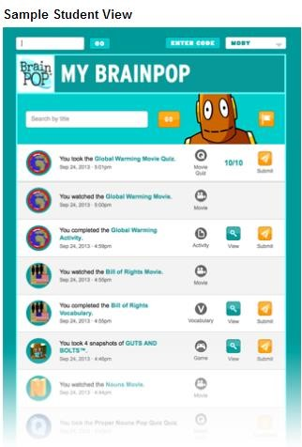
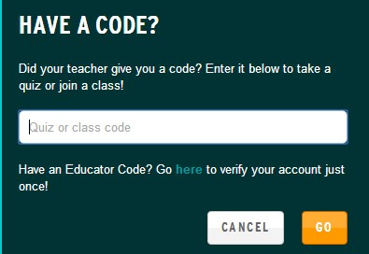
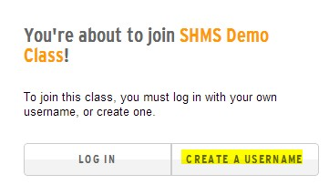
Submitting work - Students can submit work at the end of a quiz when prompted to submit scores to the teacher. If the student is part of more than one class, he or she can choose which teacher receives the responses. Students can also save and submit activity pages, or send snapshots of and reflections on game play through GameUp.

What can students do with My BrainPOP?

Receiving feedback - Students receive their scores and comments from teachers after a teacher scores or comments on a student’s work. He or she can send it back to the student.
When the student logs in to My BrainPOP, the feed will include an alert that he or she can click on.
http://www.brainpop.com/educators/community/my-brainpop-faq

To remove a student from a class: In the class, select the appropriate class tab, then click on the Class Management button. Clicking on the Edit icon next to the student’s name will give you the option of removing him or her from that class. You’ll be able to indicate
whether the student has left the school, or just your class.

How to use My BrainPOP with Your Students
My BrainPOP tracks students’ movie watching history and their score on quizzes, including those created with the Mixer. My BrainPOP also tracks their work on Activity pages. On select GameUp titles, students can take snapshots of their play and then write a reflection on what they’ve done or answer a prompt. These snapshots are also tracked by My BrainPOP.
How to Manage My BrainPOP
- Different views
    - Timeline View – Shows you all the work students have submitted to you, with the most recent activity at the top.
    - Spreadsheet View – Shows you a spreadsheet containing the work students have submitted to you. You can export that spreadsheet as a CSV file for use in Excel or a gradebook program.
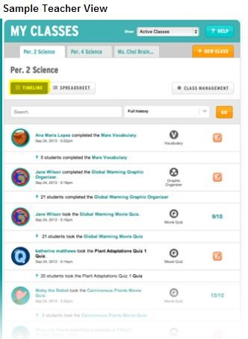

- Quizzes –
  - Most BrainPOP videos have a classic quiz for students to check for understanding after viewing. When logged into a My BrainPOP student account, a student’s score can be scored, printed, emailed, and reviewed by you.
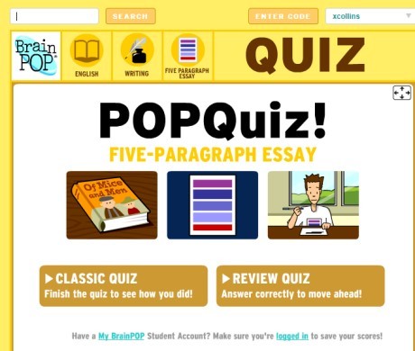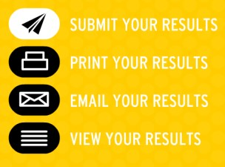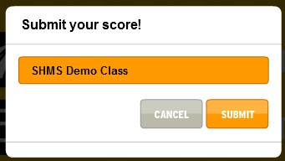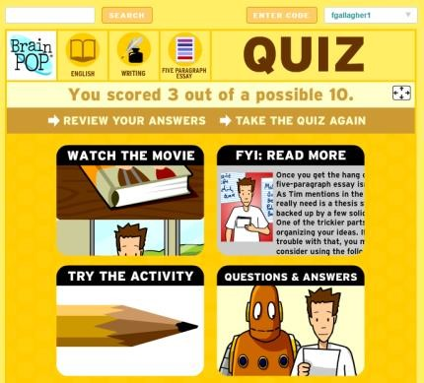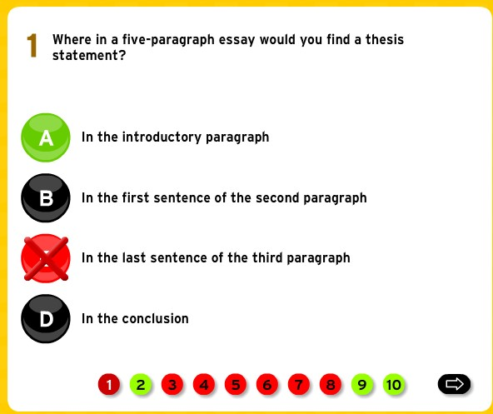
Take the quiz
as a class at
the SMART
Board!

REVIEW A QUIZ

  - My Mixer Quizzes - The Mixer™ is a tool that lets you create and share custom, BrainPOP-style quizzes. It’s a great way to tailor assessment and meet all your students’ needs. A search function gives you access to our growing library of multiple choice and open-response questions. You can add any item you like to your quiz and edit it to suit your own needs.

You also can write your own multiple choice and open response questions from scratch. When your quiz is done, you can keep it private so that only your students can see it; or you can share it with the community, giving other teachers access to your work.

Easily create quizzes on your mobile device app, too. Students can take quizzes on all devices.
How do I create a quiz?

- Go to your list of existing quizzes and click the New Quiz button. A popup will appear asking you to pick a working title and a topic for your quiz. When you click the Create button, you’re on your way!
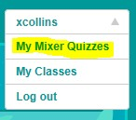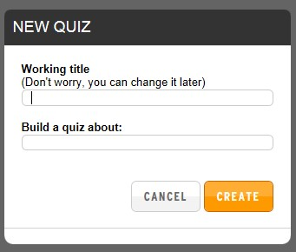

- Enter customized questions by type (multiple choice or open-ended). Upload images to include with your answers.
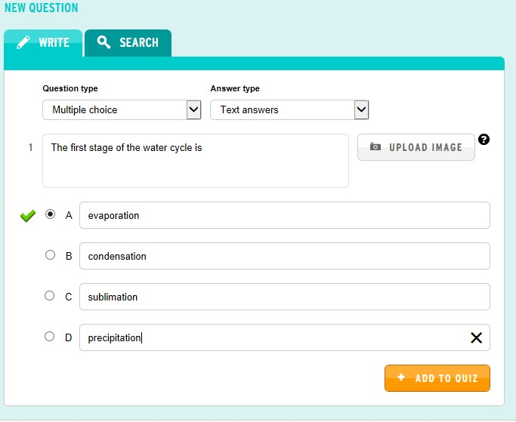

Or search for BrainPOP questions or those created by other users.
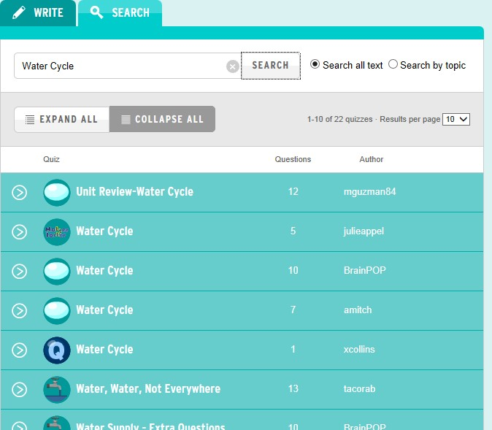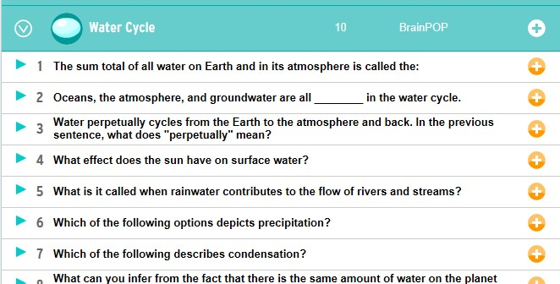

c.

Click on
Finalize

to complete your quiz.

How to Add Questions

Click on the title to see the available
questions. Then click the orange plus
sign of each question you want to
include. When you’re done, click the
white plus sign to
include in your Mixer
quiz.

  - Assign your own quiz code or auto-generate one to give to students to access and click Publish.
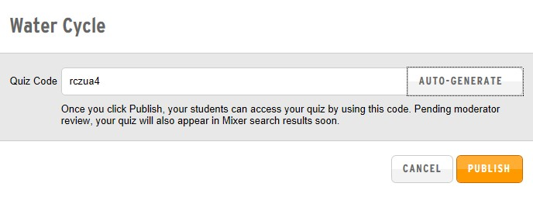

  - You can copy the link or share the code once your quiz is published with your students.
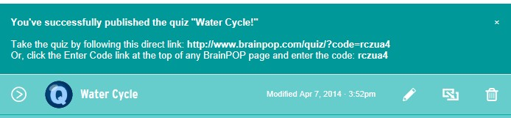

  - To Edit, click on the Pencil icon next the quiz title. To delete a quiz, click on the Trash can.
  - To create tiered quizzes for differentiation, find the quiz you want to duplicate in your list of quizzes. Click the Copy icon (between the pencil and the trash can). In the popup, click the Yes button. You now have a duplicate of the original quiz, with “(copy)” added to the end of its title. You may change the title in the quiz Settings. In the quiz settings you can edit, move, add, or delete questions.
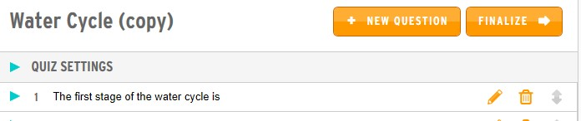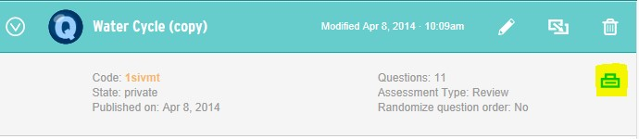

h
. To
Print

a paper copy, click the

next
to
the quiz title.
T
he
icon will turn to down when the
to
reveal your options.
Click on the printer icon

.

Submitting and Grading Tips
- Multiple choice questions will be graded automatically; however, you must grade open response questions manually.
- When your students finish a quiz, they can print their results, review them, or email them to you.
- If you’ve set up classes through My BrainPOP, students can submit completed quizzes directly to your My BrainPOP account. You will be able to score open-ended questions, make comments, and track progress, all through BrainPOP.

- Activities – Activity pages are worksheet style resources that accompany most videos. Teachers can print for students or ask students to type or draw their responses and save to their student accounts or submit to a class/teacher for grading.
Most activities include: vocabulary, review sheets, and graphic organizers.
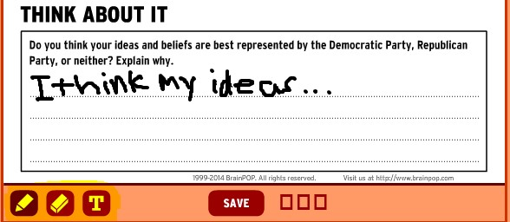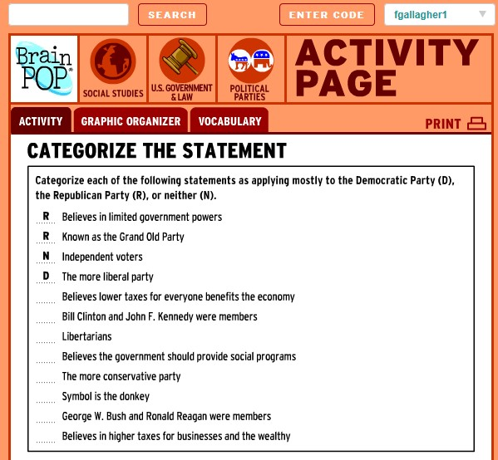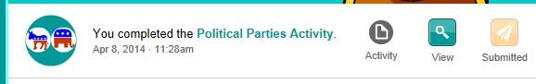

,

➔

Wr
iting tools

best used at

the SMART Board

➔

T
ext tool for typing and saving responses on the

document.

Once a stu
dent saves an activity to
to a personal
account, the option to submit to a teacher will
appear for grading.

Student view

- Q & A – Essential questions with complete answers when you click on the text.
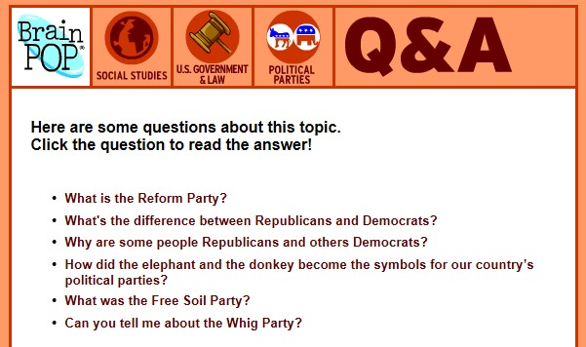

- GAME UP – Include game-based learning into your teaching with games and lessons plans found in BrainPOP and BrainPOP educators - http://www.brainpop.com/educators/community/games-main/.
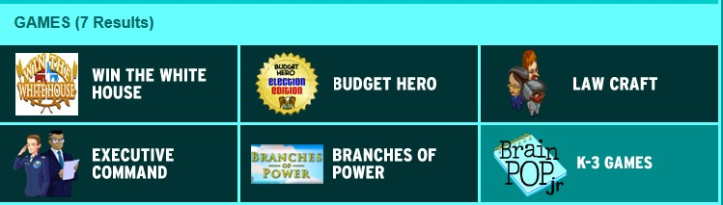

Review and grade student performance with the SnapThought photo reflection tool - http://www.brainpop.com/educators/community/video/snapthought-aphoto-reflection-tool/.

- FYI – Students can learn more additional facts and view resources related to a topic.
a. Examples - quirky stuff , current events questions, graphs and stats, in-depth investigation, and more.
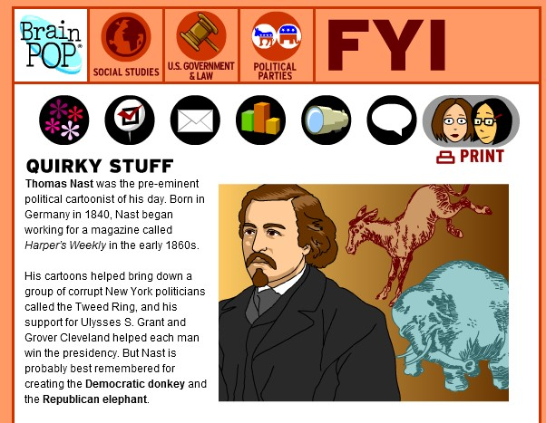

Troubleshooting

- Change or reset a student’s password
In My BrainPOP, select the appropriate class tab, then click on the Class Management button. Clicking on the Edit icon next to the student’s name will give you the option of changing the username and password. You’ll have to let the student know that you’ve made the change; there is no automatic notification system. • Closed captioning
Turn on closed captioning for any video by clicking on the CC icon located in the video player settings. Click again to turn off closed captioning.
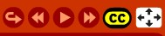
- Full Screen
View a video in full screen mode by clicking on the 4-way arrow icon in the video player settings.

