- Open the Maintenance (T:) Drive, and find the Front Ricoh Business Center Icon. If you are using thumbnails, it should look like this:
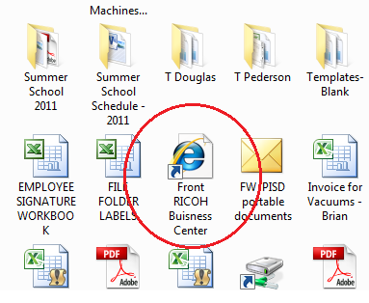
- When you have located this icon, click on it to open the link in your web browser.
- When it is open, look for the login link in the top right corner of the page. It should look like this:
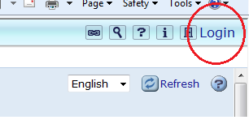
- Click this link, and the login page will open.
- When the login page has opened, type “admin” in the Login User Name field. It should look like this: 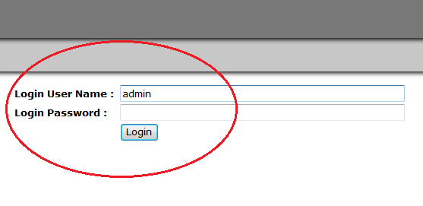
- Click “Login”
- This action should open another page.
- When this page has opened, find the “Address Book” tab on the left of the screen. It should look like this:
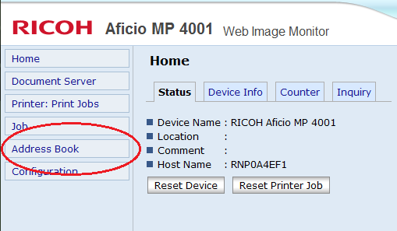
- Click this tab.
- This action should open another page.
- When this page has opened, select the address you would like to modify by clicking the dot on the left of the address list. This action should look like this:
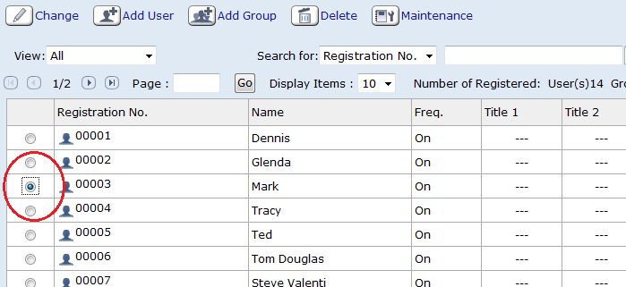
- After doing this, click “Change” located on the top left, above the list. This should open another page.
- When the page has opened, find the “Folder Authentication” section. Click Change. This is pictured below.
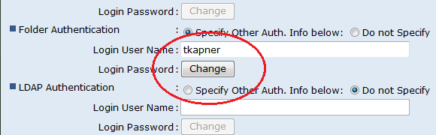
- Doing so will open another page.
- When this page has opened, ask user to type their password in both fields. This should be the password required to access their computer. This should look like this:
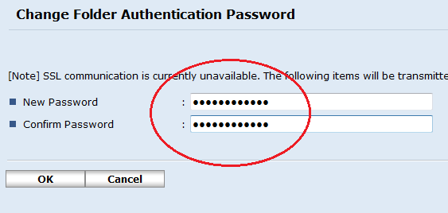
- After user completes this, click OK. Wait for the next page to load COMPLETELY.
- When page has loaded completely, scroll to the top or bottom and click OK. This should look like this:
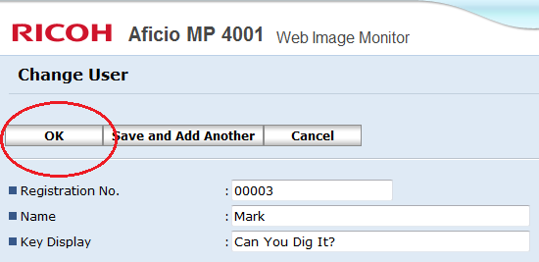
- When you have completed these actions. The scanner should function properly. Log out of the business center, and have a nice day.

